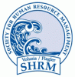 | Volusia / Flagler SHRM  March 2013  PROGRAM INFO
This program has been submitted for 1.0 strategic re-certification credit!
Program Overview:  “How to Comply with Employment Regulations”  - Rise in employee claims  - Complex employment laws  - The best practices for claim avoidance  - Most commonly made claims by employees  Speaker Information:  Greg Snell, Attorney, Snell Legal  This presenter is a licensed attorney with the Florida Bar for over 28 years. He attended Cumberland School of Law; Samford University. He has been representing employers in employment issues for more than 20yrs. He has been a Law Dragon finalist twice as one of 500 leading lawyers. Snell was awarded the Florida Super Lawyer in the area of business litigation as selected by the publishers of Law and Politics, awarded to only the top 5% of Florida lawyers. He has many published works including “Damages for Breach of a Liability Insurance Policy by an Insurer” – the Communicator-Newsletter of the Volusia County Bar Association, “Employee Claim Risk Management”, - Volusia/Flagler Business Report, “Recession Survival Tips: Surviving the Downturn Through Better Business Practices”, Volusia/Flagler Business Report, and “Time for Employment Agreement Check Up”, -The Stethoscope-Medical Bulletin of the Volusia County Medical Society. |  | Date:  Wednesday, March 20th, 2013  Location:  Daytona Beach Int’l Airport, 2nd Floor, Volusia Room    Time:  7:45am-9:00am
 |  | 
Thank you to our Diamond Chapter Sponsors Below:
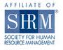


CONTACT US:

E-Mail: DaytonaSHRM@gmail.com
Address: P.O. Box 10366
Daytona Beach, Fl 32120
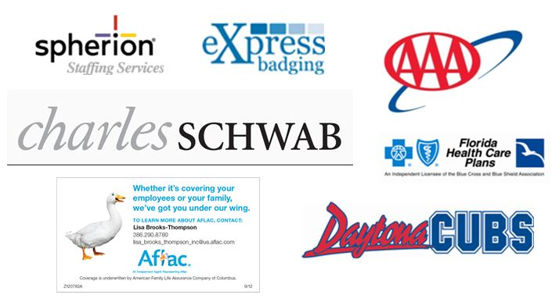
Website www.volusiaflagler.shrm.org
Click here for details on our chapter sponsorship program.

Send your inquiries to:
DaytonaSHRM@gmail.com

